SOP – Standard Transaction
Ask if they are a Thrift Plus member, if not ask them to sign up (see Thrift Plus sign up SOP)
Make sure your cursor is in the field under “Add Item”
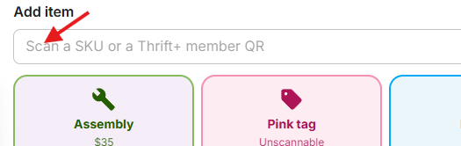

Scan QR code on our green tags with scanner, always check to make sure the scan was registered and no error codes appear in the bottom left. If you see something like the following, that means the scanner registered something other than our QR code, this could be the manufacturers barcode or a tag from the store it came from. You may need to cover up any other barcodes to ensure that ours is the only one scanned. If you do receive this error make sure you clear it before you continue scanning as it will stay until acknowledged/cleared.
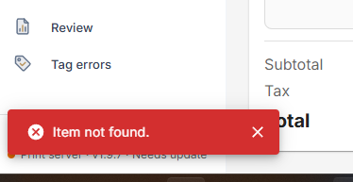

After every item has been scanned or entered, tell the customer their total. Also let them know how many Thrift bucks they earned this trip and ask them if they want to use any previously acquired thrift bucks and advise them of how much time they have left to use their thrift bucks. This information is all available to you in the upper right of your Dash screen as shown below.
screenshot
If there is a change to their total owed, let the customer know their new total and ask how they will be paying, “Cash or Card?”
For Card transactions, tap the screen of the credit card machine to get to the following screen
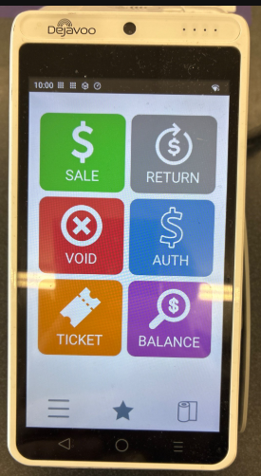
From there you will tap “Sale” at the top left
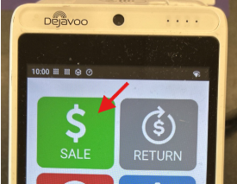
Type the amount in the following screen and tap “OK”
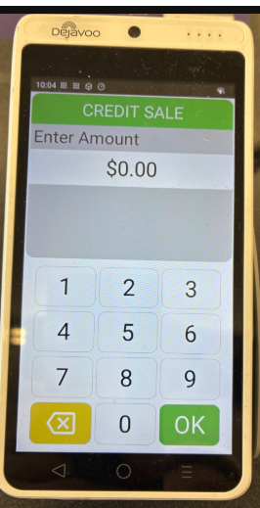
The customer then taps their card (or if necessary inserts it into the side of the machine as shown below)
Tap here:
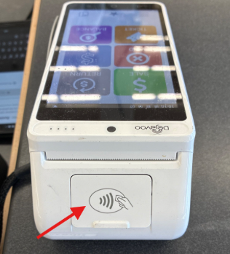
Insert here:
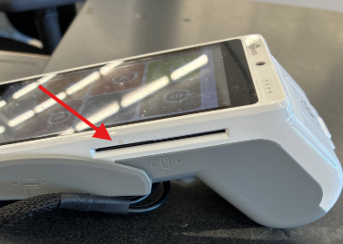
In Dash, select the Card option. After the machine indicates whether or not a surcharge is to be added, indicate in Dash whether the machine added the surcharge by selecting the corresponding option of those shown below.
This prompts Dash to print the receipt which should be offered to the customer.
For Cash, select the Cash option in Dash and indicate how many and which denominations of cash the customer gives you. This prompts Dash to tell you how much change to give (if any) and which denominations of cash or coins that change should be given in.
For the cash transaction shown below you can see that the total was $5.37 and the customer paid using a $5 bill and a $1 bill, totaling $6. The change to be given was $0.63 and Dash shows that should be given as 2 quarters, 2 nickels, (when the drawer was opened this morning there were no dimes and that was correctly indicated in Dash so it has adjusted accordingly, if the cashier had “bought” dimes from the safe at some point between now and the drawer having been opened, the change given can reflect what is actually in the drawer even if it differs from Dash, as long as the customer is given the correct amount back) and 3 pennies.
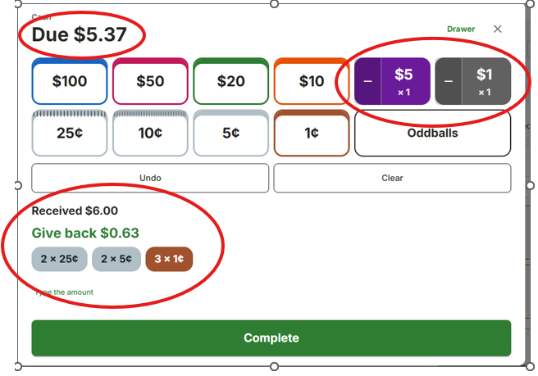
The cash drawer can be accessed using the keys shown below, either key will work but should not be left in the lock.

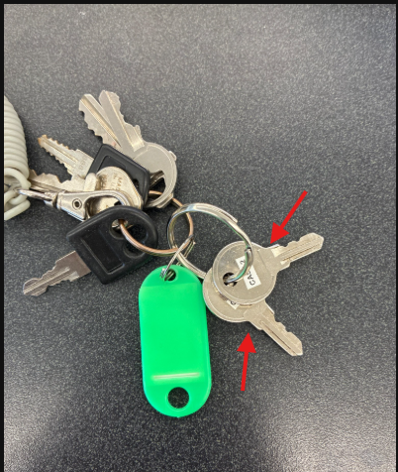
After you’ve given the customer their change, hit “complete” in Dash, prompting it to print the customer’s receipt.
After giving the customer their receipt, thank them and wish them a good day in some form (good afternoon/evening/weekend/whatever). The most important thing and the only thing we can really fully control is that each transaction starts and ends with a smile from us.

